Art and Architecture in Rome

**Introduction to ancient Roman art by (Ambler, 2015)**

With the lands of Greece, Egypt, and beyond, Ancient Rome was a melting pot of cultures.

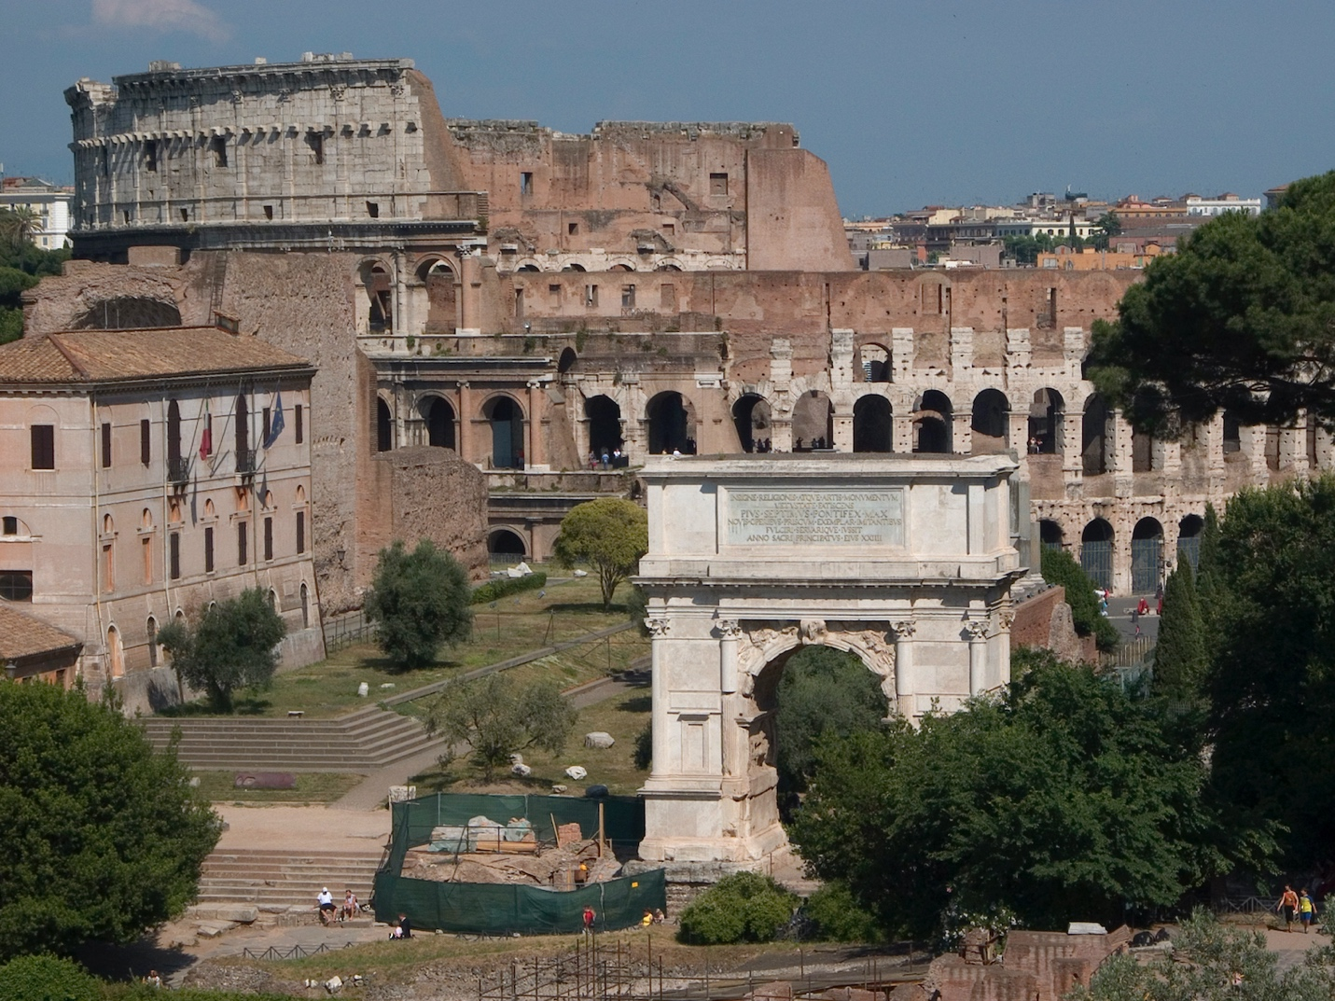

View of the Roman forum, looking toward the Colosseum (photo: [Steven Zucker](https://flic.kr/p/7WkhJi), CC BY-NC-SA 2.0)

**Roman art: when and where**

Roman art is a very broad topic, spanning almost 1,000 years and three continents, from Europe and Africa and Asia. The first Roman art can be dated back to 509 B.C.E., with the legendary founding of the Roman Republic, and lasted until 330 C.E. (or much longer, if you include [Byzantine art](https://smarthistory.org/a-beginners-guide-to-byzantine-art/)). Roman art also encompasses a broad spectrum of media including marble, painting, mosaic, gems, silver, bronze work, and terracottas, just to name a few. The city of Rome was a melting pot, and the Romans had no qualms about adapting artistic influences from the other Mediterranean cultures that surrounded and preceded them. For this reason it is common to see [Greek](https://smarthistory.org/ancient-greece-an-introduction/), [Etruscan](https://smarthistory.org/the-etruscans-an-introduction/), and [Egyptian](https://smarthistory.org/ancient-egyptian-art/) influences throughout Roman art. This is not to say that all of Roman art is derivative, though, and one of the challenges for specialists is to define what is “Roman” about Roman art.

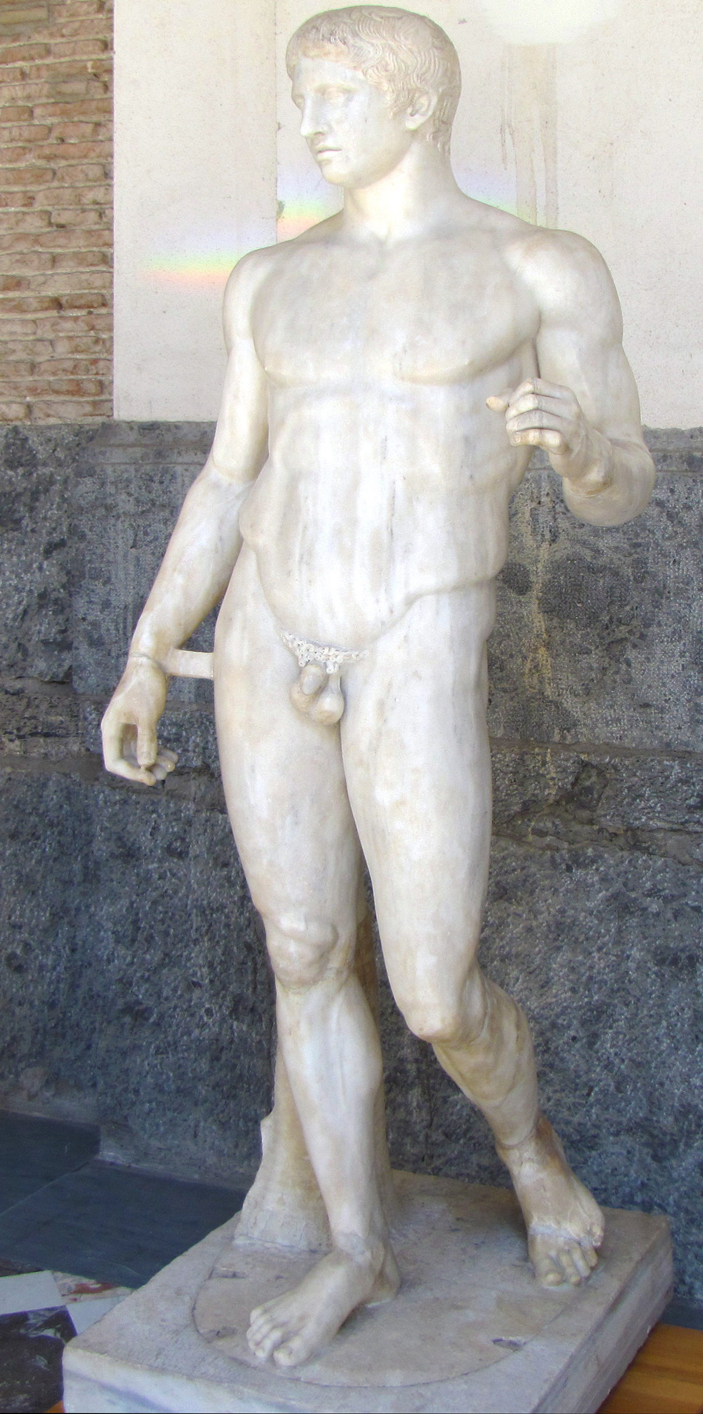

*Doryphoros (Spear Bearer)*, Roman copy after an original by the Greek sculptor Polykleitos from c. 450–40 B.C.E., marble, 211 cm high (Archaeological Museum, Naples; photo: [Steven Zucker](https://flic.kr/p/cNYXgU), CC BY-NC-SA 2.0)

Greek art certainly had a powerful influence on Roman practice; the Roman poet Horace famously said that “Greece, the captive, took her savage victor captive,” meaning that Rome (though it conquered Greece) adapted much of Greece’s cultural and artistic heritage (as well as importing many of its most famous works). It is also true that many Romans commissioned versions of famous Greek works from earlier centuries; this is why we often have marble versions of lost Greek bronzes such as the [*Doryphoros*](https://smarthistory.org/polykleitos-doryphoros-spear-bearer/) by Polykleitos.

The Romans did not believe, as we do today, that to have a copy of an artwork was of any less value that to have the original. The copies, however, were more often variations rather than direct copies, and they had small changes made to them. The variations could be made with humor, taking the serious and somber element of Greek art and turning it on its head. So, for example, a famously gruesome Hellenistic sculpture of the satyr Marsyas being flayed was converted in a Roman dining room to a knife handle (currently in the National Archaeological Museum in Perugia). A knife was the very element that would have been used to flay the poor satyr, demonstrating not only the owner’s knowledge of Greek mythology and important statuary, but also a dark sense of humor. From the direct reporting of the Greeks to the utilitarian and humorous luxury item of a Roman enthusiast, Marsyas made quite the journey. But the Roman artist was not simply copying. He was also adapting in a conscious and brilliant way. It is precisely this ability to adapt, convert, combine elements, and add a touch of humor that makes Roman art Roman.

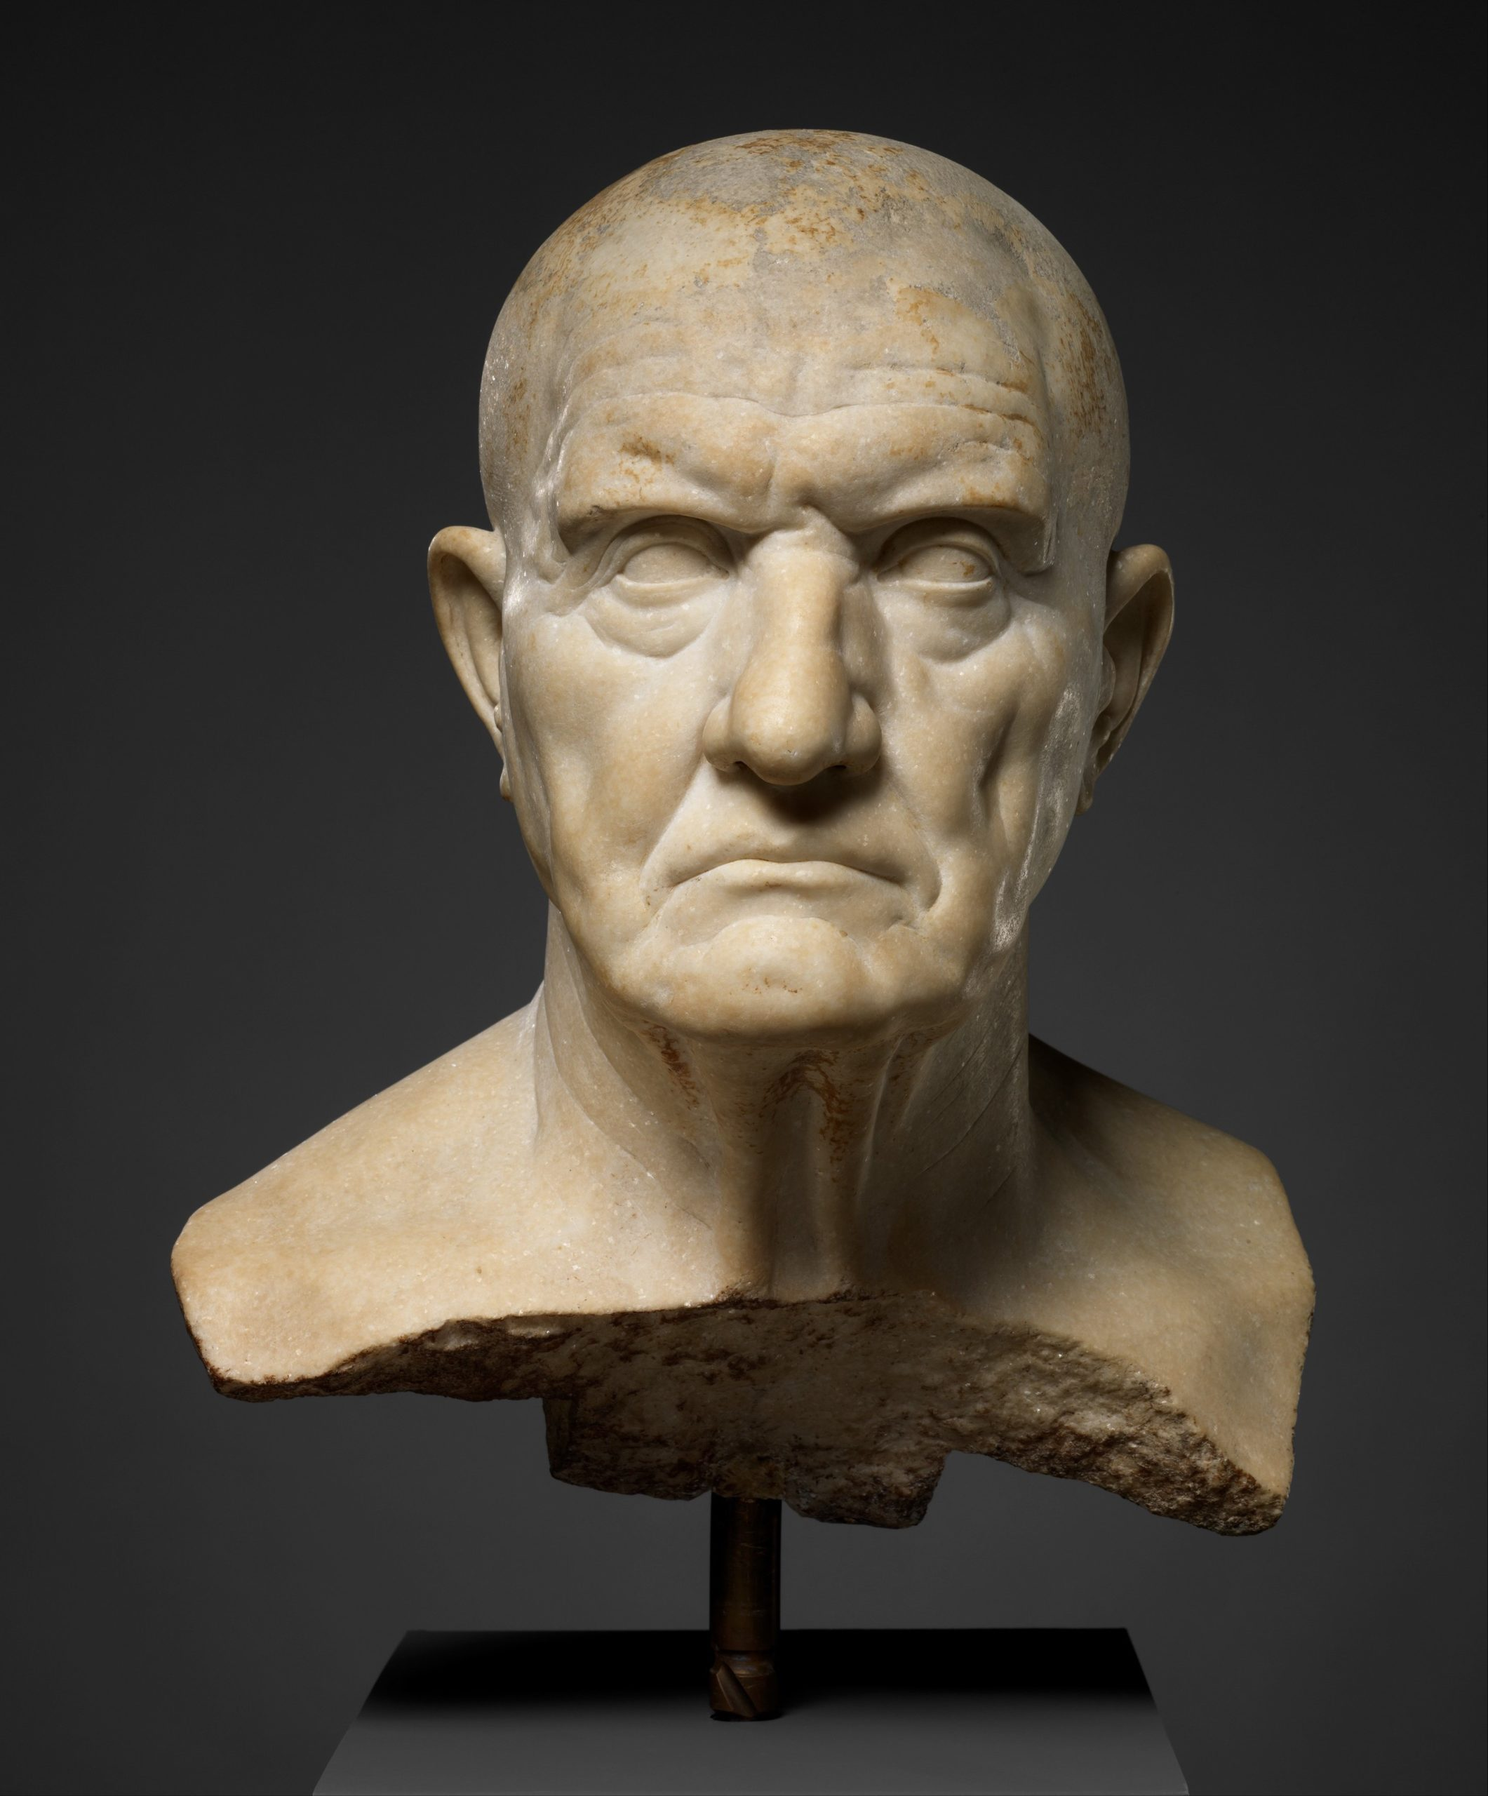

*Marble bust of a man*, mid-1st century, marble, 36.5 cm high (The Metropolitan Museum of Art, New York)

**Republican Rome**

The mythic founding of the Roman Republic is supposed to have happened in 509 B.C.E., when the last Etruscan king, Tarquinius Superbus, was overthrown. During the Republican period, the Romans were governed by annually elected magistrates, the two consuls being the most important among them, and the Senate, which was the ruling body of the state. Eventually the system broke down and civil wars ensued between 100 and 42 B.C.E. The wars were finally brought to an end when Octavian (later called Augustus) defeated Mark Antony in the Battle of Actium in 31 B.C.E.

In the Republican period, art was produced in the service of the state, depicting public sacrifices or celebrating victorious military campaigns (like the Monument of Aemilius Paullus at Delphi). Portraiture extolled the communal goals of the Republic; hard work, age, wisdom, being a community leader and soldier. Patrons chose to have themselves represented with balding heads, large noses, and extra wrinkles, demonstrating that they had spent their lives working for the Republic as model citizens, flaunting their acquired wisdom with each furrow of the brow. We now call this portrait style veristic, referring to the hyper-naturalistic features that emphasize every flaw, creating portraits of individuals with personality and essence.

**Imperial Rome**

Augustus’s rise to power in Rome signaled the end of the Roman Republic and the formation of Imperial rule. Roman art was now put to the service of aggrandizing the ruler and his family. It was also meant to indicate shifts in leadership. The major periods in Imperial Roman art are named after individual rulers or major dynasties, they are:

Augustan (27 B.C.E.–14 C.E.)  
Julio-Claudian (14–68 C.E.)  
Flavian (69–98 C.E.)  
Trajanic (98–117 C.E.)  
Hadrianic (117–38 C.E.)  
Antonine (138–93 C.E.)  
Severan (193–235 C.E.)  
Soldier Emperor (235–84 C.E.)  
Tetrarchic (284–312 C.E.)  
Constantinian (307–37 C.E.)

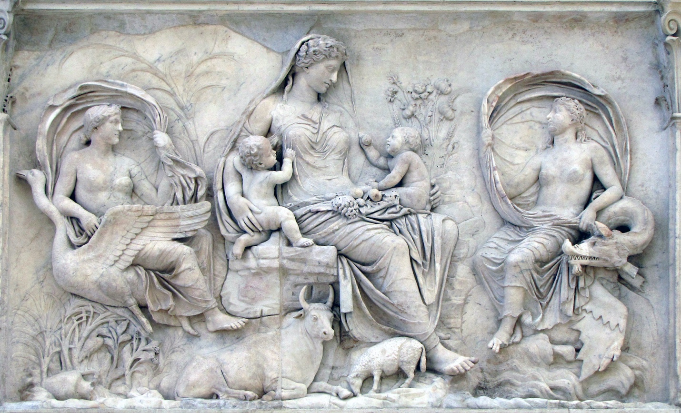

Relief from the *Ara Pacis Augustae (Altar of Augustan Peace)*, 9 B.C.E. monument is dedicated, marble (Museo dell'Ara Pacis, Rome; photo: [Steven Zucker](https://flic.kr/p/dbD7X3), CC BY-NC-SA 2.0)

Imperial art often hearkened back to the Classical art of the past. “Classical”, or “Classicizing,” when used in reference to Roman art refers broadly to the influences of Greek art from the Classical and Hellenistic periods (480–31 B.C.E.). Classicizing elements include the smooth lines, elegant drapery, idealized nude bodies, highly naturalistic forms and balanced proportions that the Greeks had perfected over centuries of practice.

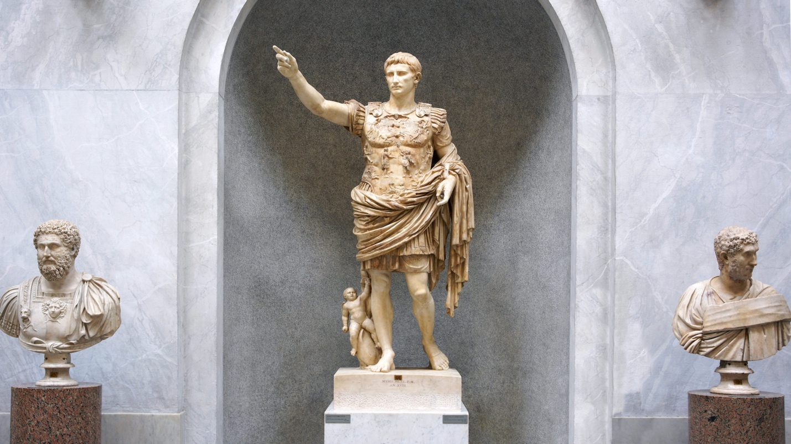

*Augustus of Primaporta*, 1st century C.E. (Vatican Museums; photo: [Steven Zucker](https://flic.kr/p/2iPqwG2), CC BY-NC-SA 2.0)

Augustus and the Julio-Claudian dynasty were particularly fond of adapting Classical elements into their art. The [*Augustus of Primaporta*](https://smarthistory.org/augustus-of-primaporta/) was made at the end of Augustus’s life, yet he is represented as youthful, idealized and strikingly handsome like a young athlete—all hallmarks of Classical art. The emperor Hadrian was known as a *philhellene*, or lover of all things Greek. The emperor himself began sporting a Greek “philosopher’s beard” in his [official portraiture](https://smarthistory.org/bronze-head-from-a-statue-of-the-emperor-hadrian/), unheard of before this time. Décor at his rambling [Villa at Tivoli](https://smarthistory.org/hadrians-imperial-palace-tivoli/) included mosaic copies of famous Greek paintings, such as *Battle of the Centaurs and Wild Beasts* by the legendary ancient Greek painter Zeuxis.

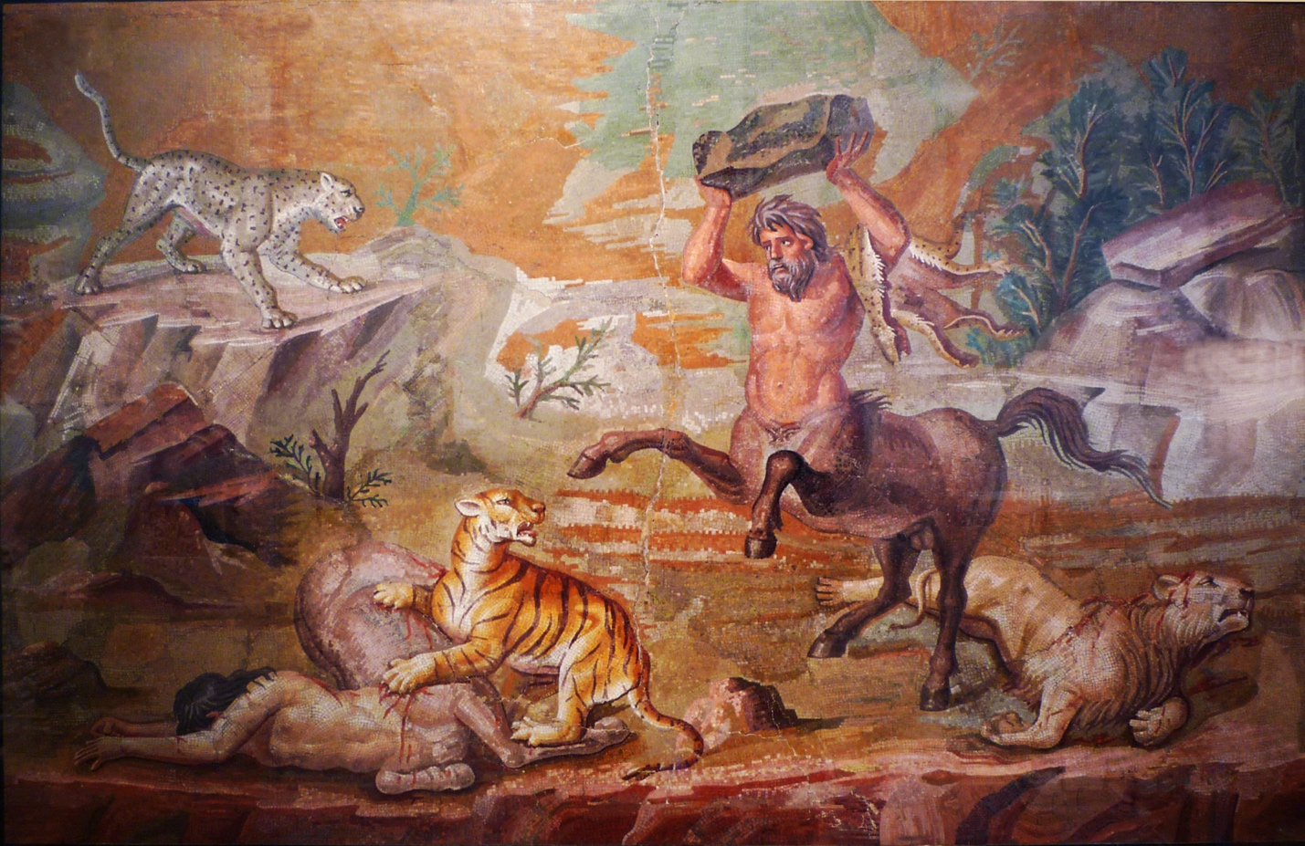

*Pair of Centaurs Fighting Cats of Prey from Hadrian's Villa*, mosaic, c. 130 C.E. (Altes Museum, Berlin, photo: [Steven Zucker](https://flic.kr/p/CptMgk), CC BY-NC-SA 2.0)

Later Imperial art moved away from earlier Classical influences, and Severan art signals the shift to art of Late Antiquity. The characteristics of Late Antique art include frontality, stiffness of pose and drapery, deeply drilled lines, less naturalism, squat proportions, and lack of individualism. Important figures are often slightly larger or are placed above the rest of the crowd to denote importance.

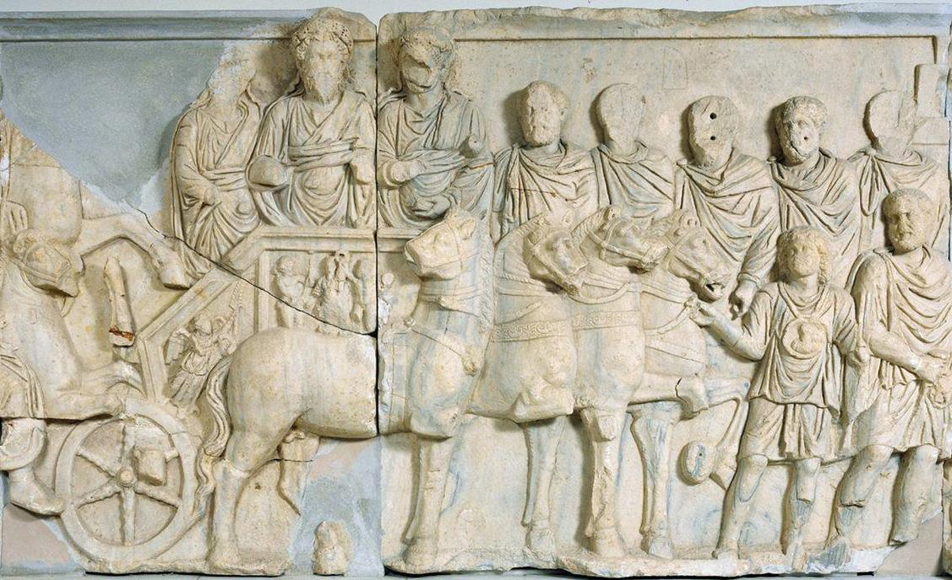

*Chariot procession of Septimus Severus*, relief from the attach of the Arch of Septimus Severus, Leptis Magna, Libya, 203 C.E., marble, 167 cm high (Red Castle Museum, Tripoli)

In relief panels from the *Arch of Septimius Severus* from Lepcis Magna, Septimius Severus and his sons, Caracalla and Geta ride in a chariot, marking them out from an otherwise uniform sea of repeating figures, all wearing the same stylized and flat drapery. There is little variation or individualism in the figures and they are all stiff and carved with deep, full lines. There is an ease to reading the work; Septimius is centrally located, between his sons and slightly taller; all the other figures direct the viewer’s eyes to him.

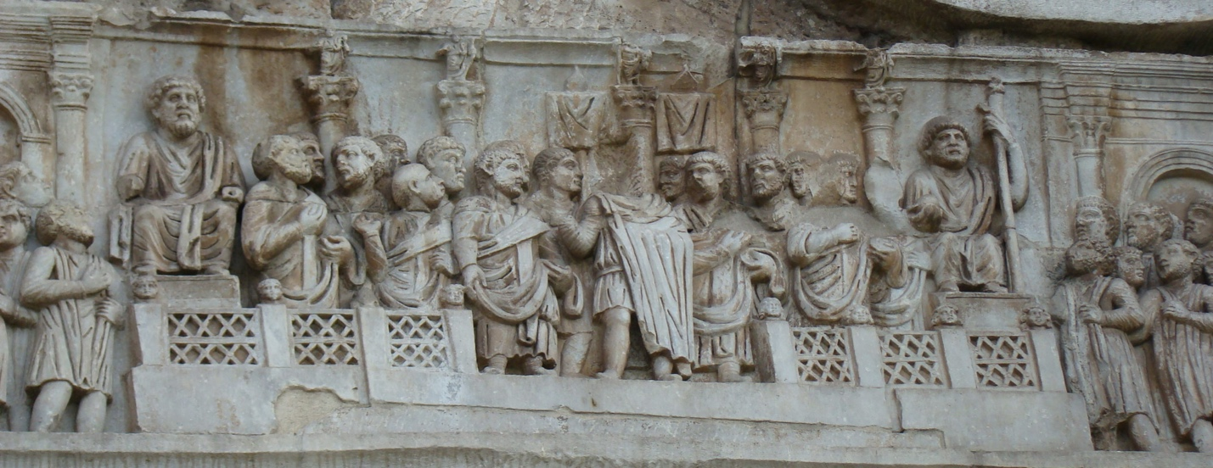

Relief from the Arch of Constantine, 315 C.E., Rome (photo: [F. Tronchin](https://flic.kr/p/4Aq4Mj), CC BY-NC-ND 2.0)

Constantinian art continued to integrate the elements of Late Antiquity that had been introduced in the Severan period, but they are now developed even further. For example, on the oratio relief panel on the [Arch of Constantine](https://smarthistory.org/arch-of-constantine-rome/), the figures are even more squat, frontally oriented, similar to one another, and there is a clear lack of naturalism. Again, the message is meant to be understood without hesitation: Constantine is in power.

**Who made Roman art?**

We don’t know much about who made Roman art. Artists certainly existed in antiquity but we know very little about them, especially during the Roman period, because of a lack of documentary evidence such as contracts or letters. What evidence we do have, such as Pliny the Elder’s *Natural History*, pays little attention to contemporary artists and often focuses more on the Greek artists of the past. As a result, scholars do not refer to specific artists but consider them generally, as a largely anonymous group.

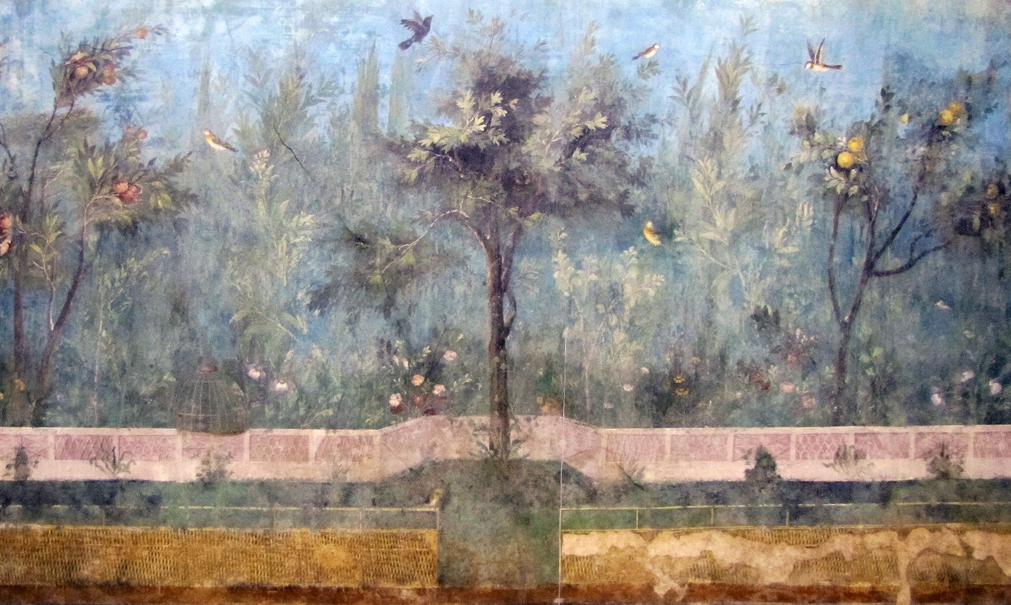

*Painted Garden*, removed from the triclinium (dining room) in the Villa of Livia Drusilla, Prima Porta, fresco, 30–20 B.C.E. (Museo Nazionale Romano, Palazzo Massimo, Rome; photo: [Steven Zucker](https://flic.kr/p/cHrrts), CC BY-NC-SA 2.0)

**What did they make?**

Roman art encompasses private art made for Roman homes as well as art in the public sphere. The [elite Roman home](https://smarthistory.org/the-villa/) provided an opportunity for the owner to display his wealth, taste and education to his visitors, dependents, and clients. Since Roman homes were regularly visited and were meant to be viewed, their decoration was of the utmost importance. Wall paintings, mosaics, and sculptural displays were all incorporated seamlessly with small luxury items such as bronze figurines and silver bowls. The subject matter ranged from busts of important ancestors to mythological and historical scenes, still lifes, and landscapes—all to create the idea of an erudite patron steeped in culture.

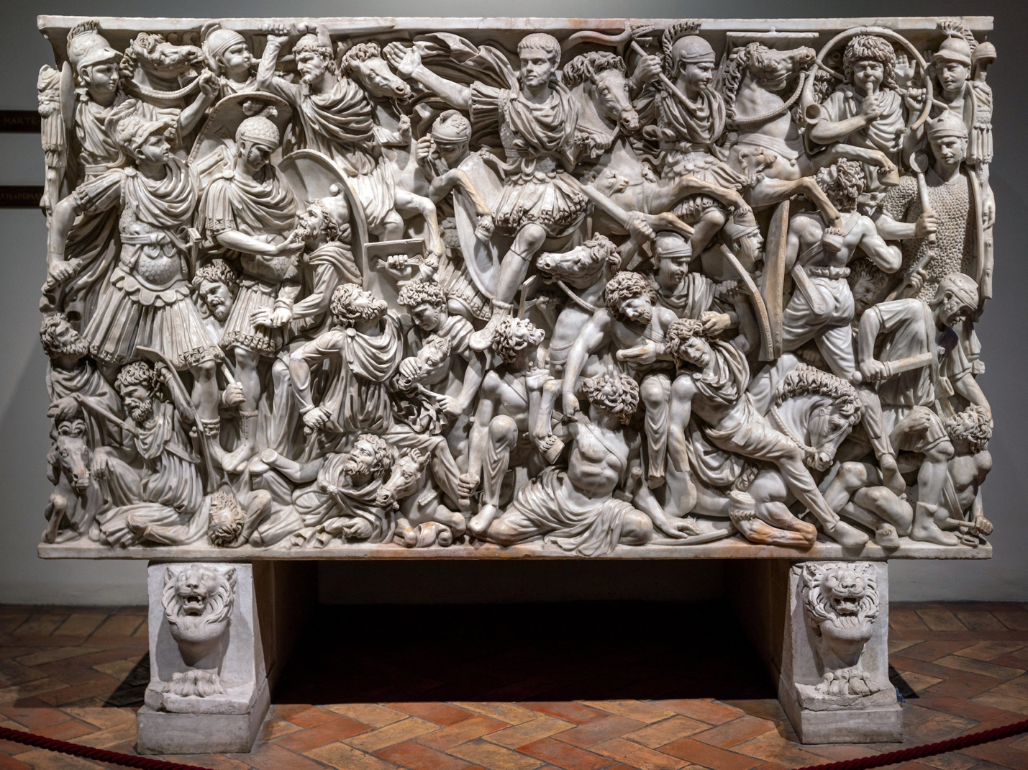

*Ludovisi Battle Sarcophagus: Battle of Romans and Barbarians*, c. 250–60 C.E., preconneus marble, 150 cm high (Palazzo Altemps: Museo Nazionale Romano, Rome; photo: [Steven Zucker](https://flic.kr/p/2n3BT6A), CC BY-NC-SA 2.0)

When Romans died, they left behind imagery that identified them as individuals. [Funerary imagery](https://smarthistory.org/roman-funeral-rituals-and-social-status-the-amiternum-tomb-and-the-tomb-of-the-haterii/) often emphasized unique physical traits or trade, partners or favored deities. Roman funerary art spans several media and all periods and regions. It included portrait busts, wall reliefs set into working-class group tombs (like those at Ostia), and elite decorated tombs (like the Via delle Tombe at Pompeii). In addition, there were painted [Faiyum portraits](https://smarthistory.org/egyptian-mummy-portraits-faiyum-portraits/) placed on mummies and sarcophagi. Because death touched all levels of society—men and women, emperors, elites, and freedmen—funerary art recorded the diverse experiences of the various peoples who lived in the Roman empire.

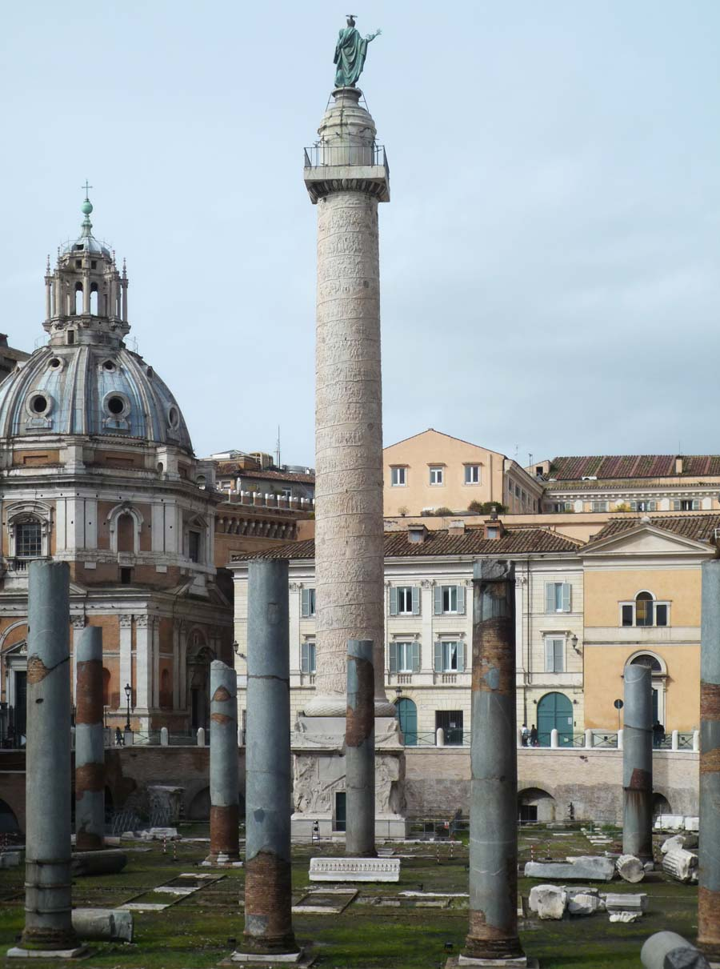

Column of Trajan, Carrera marble, completed 113 C.E., Rome, dedicated to Emperor Trajan in honor of his victory over Dacia (now Romania) 101–02 and 105–06 C.E. (photo: [Steven Zucker](https://flic.kr/p/84aNMa), CC BY-NC-SA 2.0)

The public sphere is filled with works commissioned by the emperors such as portraits of the imperial family or bath houses decorated with copies of important Classical statues. There are also commemorative works like the triumphal arches and columns that served a didactic as well as a celebratory function. The arches and columns (like the [Arch of Titus](https://smarthistory.org/the-arch-of-titus/) or the [Column of Trajan](https://smarthistory.org/column-of-trajan/)), marked victories, depicted war, and described military life. They also revealed foreign lands and enemies of the state. They could also depict an emperor’s successes in domestic and foreign policy rather than in war, such as Trajan’s Arch in Benevento. Religious art is also included in this category, such as the cult statues placed in Roman temples that stood in for the deities they represented, like Venus or Jupiter. Gods and religions from other parts of the empire also made their way to Rome’s capital including the Egyptian goddess Isis, the Persian god Mithras, and ultimately [Christianity](https://smarthistory.org/early-christian-art-and-architecture-after-constantine/). Each of these religions brought its own unique sets of imagery to inform proper worship and instruct their sect’s followers.

It can be difficult to pinpoint just what is Roman about Roman art, but it is the ability to adapt, to take in and to uniquely combine influences over centuries of practice that made Roman art distinct.

Roman architecture by (Cartwright, 2018)

Definition



by [**Mark Cartwright**](https://www.worldhistory.org/user/markzcartwright/)  
published on 14 March 2018

Available in other languages: [**Dutch**](https://www.worldhistory.org/trans/nl/1-11581/romeinse-architectuur/), [**French**](https://www.worldhistory.org/trans/fr/1-11581/architecture-romaine-antique/), [**Italian**](https://www.worldhistory.org/trans/it/1-11581/architettura-romana/), [**Portuguese**](https://www.worldhistory.org/trans/pt/1-11581/arquitetura-romana/), [**Spanish**](https://www.worldhistory.org/trans/es/1-11581/arquitectura-romana/), [**Turkish**](https://www.worldhistory.org/trans/tr/1-11581/roma-mimarisi/)

[Subscribe to topic](https://www.worldhistory.org/interestemails/?tags=aqueduct+architecture+Byzantine_Architecture+Circus_Maximus+Colosseum+column+Donato_Bramante+Empuries+Etruscan_Architecture+Filippo_Brunelleschi+Glanum+Leon_Battista_Alberti+Library_of_Celsus+Pantheon+pompeii+Roman_Architecture+Roman_Baths+Roman_Empire+Roman_Engineering+Roman_Forum+Roman_Republic+Rome+Segesta+Trajans_Column+Triumphal_Arch+Verona+Vitruvius) [Subscribe to author](https://www.worldhistory.org/interestemails/?author=markzcartwright) Print Article PDF

**[[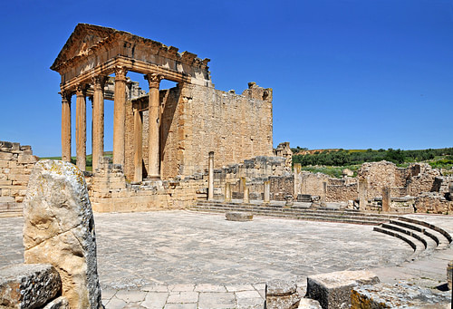](https://www.worldhistory.org/image/5142/capitolium-thugga/)](https://www.worldhistory.org/image/5142/capitolium-thugga/" \o "Capitolium, Thugga)**

[Capitolium, Thugga](https://www.worldhistory.org/image/5142/capitolium-thugga/" \o "Capitolium, Thugga)

[Dennis Jarvis (CC BY-SA)](https://www.worldhistory.org/image/5142/capitolium-thugga/" \o "Capitolium, Thugga)

[**Roman**](https://www.worldhistory.org/disambiguation/Roman/) [**architecture**](https://www.worldhistory.org/disambiguation/architecture/) continued the legacy left by [**Greek**](https://www.worldhistory.org/disambiguation/greek/) architects and the established architectural orders, especially the Corinthian. The Romans were also innovators and they combined new construction techniques and materials with creative design to produce a whole range of brand new architectural structures. Typical innovative Roman buildings included the basilica, [**triumphal arch**](https://www.worldhistory.org/Triumphal_Arch/), monumental [**aqueduct**](https://www.worldhistory.org/aqueduct/), [**amphitheatre**](https://www.worldhistory.org/amphitheatre/), and residential housing block.

Many of the Roman architectural innovations were a response to the changing practical needs of Roman society, and these projects were all backed by a state apparatus which funded, organised, and spread them around the Roman world, guaranteeing their permanence so that many of these great edifices survive to the present day.

**The Architectural Orders**

Roman architects continued to follow the guidelines established by the classical orders the Greeks had first shaped: Doric, Ionic, and Corinthian. The Corinthian was particularly favoured and many Roman buildings, even into Late Antiquity, would have a particularly Greek look to them. The Romans did, however, add their own ideas and their version of the Corinthian capital became much more decorative, as did the cornice - see, for example, the Arch of [**Septimius Severus**](https://www.worldhistory.org/Septimius_Severus/) in [**Rome**](https://www.worldhistory.org/Rome/) (203 CE). The Romans also created the composite capital which mixed the volute of the Ionic order with the acanthus leaves of the Corinthian. The Tuscan [**column**](https://www.worldhistory.org/column/) was another adaptation of a traditional idea which was a form of Doric column but with a smaller capital, more slender shaft without flutes, and a moulded base. The Tuscan column (as it came to be known in the Renaissance period) was especially used in domestic architecture such as peristyles and verandahs. The Romans also favoured monolithic columns rather than the Greek approach of using several drums stacked on top of each other.

**All buildings must be executed in such a way as to take account of durability, utility & beauty.**[**Vitruvius**](https://www.worldhistory.org/Vitruvius/)

In addition, columns continued to be used even when they were no longer structurally necessary. This was to give buildings a traditional and familiar look, for example the front of the [**Pantheon**](https://www.worldhistory.org/Pantheon/) (c. 125 CE) in Rome. Columns could be detached from the building yet remain attached to the façade at the base and entablature (free-standing columns); see, for example, [**Hadrian**](https://www.worldhistory.org/hadrian/)'s Library in [**Athens**](https://www.worldhistory.org/Athens/) (132 CE). Finally, columns could become a part of the [**wall**](https://www.worldhistory.org/wall/) itself (engaged columns) and function as pure decoration, for example, the upper floors of the [**Colosseum**](https://www.worldhistory.org/Colosseum/) exterior (last quarter 1st century CE).

Greek influence is also evidenced in the fact that late Republican innovation, such as the basilica and bath buildings, usually occurred first in the south of [**Italy**](https://www.worldhistory.org/italy/) in Campania (see especially [**Pompeii**](https://www.worldhistory.org/pompeii/)) which was closer to the long-established Greek colonies of [**Magna Graecia**](https://www.worldhistory.org/Magna_Graecia/). It was from here that we have the oldest surviving dome building, the *frigidarium* (cold room) of the Stabian Baths at Pompeii (2nd century BCE). As with many other areas, the Romans took an idea and pushed it to its maximum possibility, and the huge imperial bath complexes incorporated soaring arches, arches springing directly from column capitals, and domes which spanned seemingly impossible distances.

**[[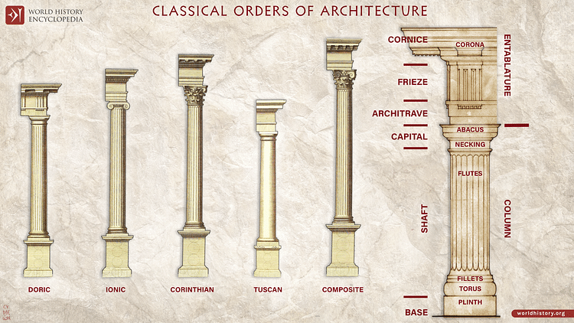](https://www.worldhistory.org/image/948/the-classical-orders-of-architecture/)](https://www.worldhistory.org/image/948/the-classical-orders-of-architecture/" \o "The Classical Orders of Architecture)**

[The Classical Orders of Architecture](https://www.worldhistory.org/image/948/the-classical-orders-of-architecture/" \o "The Classical Orders of Architecture)

[Simeon Netchev (CC BY-NC-ND)](https://www.worldhistory.org/image/948/the-classical-orders-of-architecture/" \o "The Classical Orders of Architecture)

The Augustan period saw a surge in building activity, innovation in design, and extravagant use of marble, symptoms of a Rome that was beginning to flex its muscles and with an increased confidence break away from the rigid tradition of earlier civilizations. This was also the time when increased imperial patronage allowed for ever bigger and more impressive building projects to be undertaken, not only in Rome itself but across the [**Empire**](https://www.worldhistory.org/empire/), where buildings became propaganda for the might and perceived cultural superiority of the Roman world.

As the Empire expanded, ideas and even craftsmen became integrated into the Roman architectural industry, often following their familiar materials like marble to the sites of construction. The evidence of eastern influence can be seen in such features as papyrus leaves in capitals, sculptured pedestals, street colonnades, and the *nymphaeum* (ornamental fountain).

**Materials & Techniques**

The first all-marble building was the [**Temple**](https://www.worldhistory.org/temple/) of [**Jupiter**](https://www.worldhistory.org/jupiter/) Stator in Rome (146 BCE), but it was not until the Empire that the use of marble became more widespread and the stone of choice for the most impressive state-funded building projects. The most commonly used from Italy was Carrara (Luna) marble from Tuscany (see, for example, the 30 BCE Temple of [**Apollo**](https://www.worldhistory.org/apollo/) on the Palatine). Marble was also readily available from across the empire; especially esteemed were the Parian marble of [**Paros**](https://www.worldhistory.org/Paros/) in the [**Cyclades**](https://www.worldhistory.org/Cyclades/) and Pentelic from Athens. Coloured varieties were also much favoured by Roman architects, for example, yellow Numidian marble from North [**Africa**](https://www.worldhistory.org/disambiguation/africa/), purple Phyrgian from central [**Turkey**](https://www.worldhistory.org/Asia_Minor/), red porphyry from [**Egypt**](https://www.worldhistory.org/egypt/), and green-veined Carystian marble from Euboea. Foreign marble was, though, mainly reserved for use in columns and, due to the costs of transportation, imperial projects.

**[[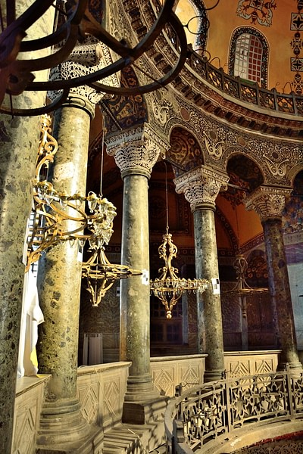](https://www.worldhistory.org/image/7971/columns-of-hagia-sophia/)](https://www.worldhistory.org/image/7971/columns-of-hagia-sophia/" \o "Columns of Hagia Sophia)**

[Columns of Hagia Sophia](https://www.worldhistory.org/image/7971/columns-of-hagia-sophia/" \o "Columns of Hagia Sophia)

[Hagia Sophia Research Team (CC BY-NC-SA)](https://www.worldhistory.org/image/7971/columns-of-hagia-sophia/" \o "Columns of Hagia Sophia)

Besides marble, travertine white limestone was also made available from quarries near Tivoli, and its favourability towards precise carving and inherent load-bearing strength made it a favourite substitute for marble amongst Roman architects from the 1st century BCE. It was especially used for paving, door and window frames, and steps.

The Romans did not invent lime mortar but they were the first to see the full possibilities of using it to produce concrete. Concrete rubble had usually been reserved for use as a filler material but Roman architects realised that the material could support great weight and could, therefore, with a little imagination, be used to help span space and create a whole new set of building opportunities. They called this material *opus caementicium* from the stone aggregate (*caementa*) which was mixed with the lime mortar. The material had a thick consistency when prepared and so was laid not poured like modern concrete. The first documented evidence of its use is from 3rd century BCE Cosa and its first use in Rome seems to have been a 2nd century BCE warehouse. Also in the 2nd century BCE it was discovered that by using pozzolana (concrete made using volcanic sand, *pulvis puteolanus*), which had a high silica content, the concrete could set under water and was even stronger than normal concrete. By the 1st century BCE its use seems widespread in foundations, walls, and vaults. Perhaps the best example of its possibilities in construction is the [**Sanctuary of Fortuna Primigenia at Palestrina**](https://www.worldhistory.org/article/1643/sanctuary-of-fortuna-primigenia-at-palestrina/).

**In addition to the structural possibilities offered by concrete, the material was also a lot cheaper than solid stone.**

In addition to the structural possibilities offered by concrete, the material was also a lot cheaper than solid stone and could be given a more presentable façade using stucco, marble veneer, or another relatively cheap material: fired brick or terracotta. Sun-dried mud bricks had been used for centuries and continued to be used for more modest projects up to the 1st century CE, but fired bricks had the advantage of durability and could be carved just like stone to resemble such standard architectural features as capitals and dentils.

Bricks were typically 59 cm square and 2.5-5 cm thick. Uncut they were used in roofing and drains, but for other uses they were usually cut into 18 triangles. There were also circular bricks, typically cut into quarters, which were used for columns. Bricks could also be used in domes such as that of the Temple of [**Asklepios**](https://www.worldhistory.org/Asclepius/) Soter at [**Pergamon**](https://www.worldhistory.org/pergamon/) and even became a decorative feature themselves by using different coloured bricks (usually yellow and orange) and laid to create patterns.

**[[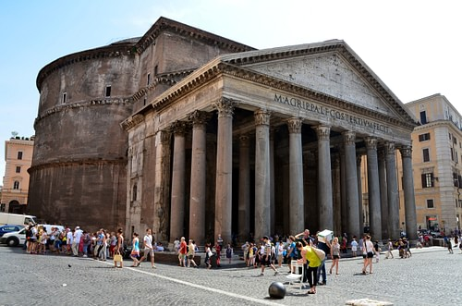](https://www.worldhistory.org/image/1272/pantheon-rome/)](https://www.worldhistory.org/image/1272/pantheon-rome/" \o "Pantheon, Rome)**

[Pantheon, Rome](https://www.worldhistory.org/image/1272/pantheon-rome/" \o "Pantheon, Rome)

[Jack G (CC BY-NC-SA)](https://www.worldhistory.org/image/1272/pantheon-rome/" \o "Pantheon, Rome)

Stucco was used to face brick walls and could be carved, like bricks could be, to reproduce the architectural decorations previously rendered only in stone. The stucco was made from a mix of sand, gypsum, and even marble dust in the best quality material.

Volcanic tufa and pumice were used in domes because of their light weight as in, for example, the Pantheon. Basalt was often used for paving and roads, laid as polygonal blocks, and [**Egyptian**](https://www.worldhistory.org/disambiguation/Egyptian/) grey and pink granite was popular for obelisks and columns. Finally, terracotta was also used for moulded ornamentation on buildings and became a common embellishment of private homes and tombs.

**Roman Architects by (Cartwright, 2017)**

In the Roman world the credit for buildings was largely placed at the feet of the person who conceived and paid for the project rather than the architect who oversaw the realisation of it; therefore, he often remains anonymous. Those architects employed for specific projects by the emperor are better known. We know of [**Trajan**](https://www.worldhistory.org/trajan/)'s favoured architect, Apollodorus of Damascus, famed for his skills in bridge building, for example, and who was responsible for, amongst other projects, Trajan's Forum and Baths in Rome (104-9 CE). Severus and Celer were the architects responsible for the fantastic sounding revolving roof of [**Nero**](https://www.worldhistory.org/Nero/)'s Golden House. In general, architects supervised whilst it was contractors (*redemptores*) who actually carried out the project based on the architect's measured drawings.

[[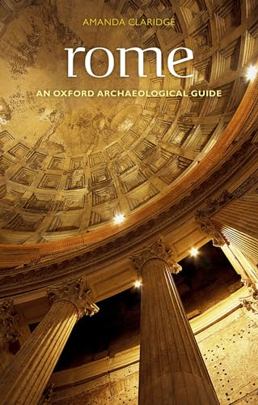](https://www.amazon.com/dp/0199546835?tag=anciehistoenc-20&linkCode=ogi&th=1&psc=1)](https://www.amazon.com/dp/0199546835?tag=anciehistoenc-20&linkCode=ogi&th=1&psc=1)

[Book Recommendation](https://www.amazon.com/dp/0199546835?tag=anciehistoenc-20&linkCode=ogi&th=1&psc=1)

**[Rome](https://www.amazon.com/dp/0199546835?tag=anciehistoenc-20&linkCode=ogi&th=1&psc=1)**

[by Claridge, Amanda & Toms, Judith & Cubberley, Tony](https://www.amazon.com/dp/0199546835?tag=anciehistoenc-20&linkCode=ogi&th=1&psc=1)

[published by Oxford University Press (2010)](https://www.amazon.com/dp/0199546835?tag=anciehistoenc-20&linkCode=ogi&th=1&psc=1)

[$30.55](https://www.amazon.com/dp/0199546835?tag=anciehistoenc-20&linkCode=ogi&th=1&psc=1)

Certainly, the most famous Roman architect is Vitruvius, principally because his *On Architecture*, a 10-volume study of architecture, has survived intact. We do not actually know much about his own work - only a basilica he constructed in Fano and that he did work for [**Julius Caesar**](https://www.worldhistory.org/Julius_Caesar/) and [**Augustus**](https://www.worldhistory.org/augustus/). *On Architecture* covers all facets of architecture, types of building, advice for would-be architects, and much more besides. One interesting point about the work is that it reveals that the ancient architect was expected to have many skills which nowadays would be separated into different specialisations. Vitruvius also encapsulated the essential ethos of Roman architecture: 'All buildings must be executed in such a way as to take account of durability, utility and beauty.' (*On Architecture*, Book I, Ch. III)

**[[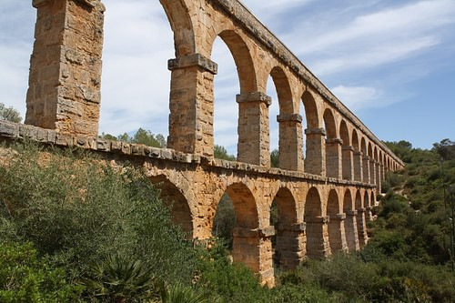](https://www.worldhistory.org/image/5537/pont-del-diable-aqueduct-tarraco/)](https://www.worldhistory.org/image/5537/pont-del-diable-aqueduct-tarraco/" \o "Pont del Diable Aqueduct, Tarraco)**

[Pont del Diable Aqueduct, Tarraco](https://www.worldhistory.org/image/5537/pont-del-diable-aqueduct-tarraco/" \o "Pont del Diable Aqueduct, Tarraco)

[Mark Cartwright (CC BY-NC-SA)](https://www.worldhistory.org/image/5537/pont-del-diable-aqueduct-tarraco/" \o "Pont del Diable Aqueduct, Tarraco)

**Key Roman Buildings**

[**Aqueducts**](https://www.worldhistory.org/aqueduct/)**& Bridges** - These sometimes massive structures, with single, double, or triple tiers of arches, were designed to carry fresh water to urban centres from sources sometimes many kilometres away. The earliest in Rome was the Aqua Appia (312 BCE), but the most impressive example is undoubtedly the Pont du Gard near Nimes (c. 14 CE). Roman bridges could make similar use of the arch to span rivers and ravines. Constructed with a flat wooden superstructure over stone piers or arches, examples still survive today. One of the best preserved is the granite Tagus Bridge at Alcantara (106 CE) which has arches spanning over 30 metres.

**Basilicas** - The basilica was adopted by the Christian church but was conceived by the Romans as a place for any large gathering, with the most common use being [**law**](https://www.worldhistory.org/disambiguation/law/) courts. They were usually built along one side of the forum, the [**city**](https://www.worldhistory.org/city/)'s marketplace, which was enclosed on all sides by colonnades. The basilica's long hall and roof were supported by columns and piers on all sides. The columns created a central nave flanked on all sides by an aisle. A gallery ran around the first floor and later there was an apse at one or both ends. A typical example is the Severan Basilica at [**Lepcis Magna**](https://www.worldhistory.org/Lepcis_Magna/) (216 CE).

**[[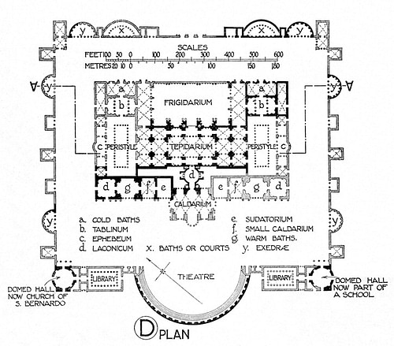](https://www.worldhistory.org/image/1174/plan-of-the-baths-of-diocletian/)](https://www.worldhistory.org/image/1174/plan-of-the-baths-of-diocletian/" \o "Plan of the Baths of Diocletian)**

[Plan of the Baths of Diocletian](https://www.worldhistory.org/image/1174/plan-of-the-baths-of-diocletian/" \o "Plan of the Baths of Diocletian)

[B. Fletcher (Public Domain)](https://www.worldhistory.org/image/1174/plan-of-the-baths-of-diocletian/" \o "Plan of the Baths of Diocletian)

**Baths** - [**Roman baths**](https://www.worldhistory.org/Roman_Baths/) display the typical Roman ability for creating breath-taking interior space using arches, domes, vaults, and buttresses. The largest of these often huge complexes were built symmetrically along a single axis and included pools, cold and hot rooms, fountains, libraries, under-floor heating, and sometimes inter-wall heating through terracotta piping. Their exteriors were usually plain, but within they were often sumptuous with the lavish use of columns, marble, statues and mosaics. One of the finest and certainly best surviving examples is the Baths of [**Caracalla**](https://www.worldhistory.org/Caracalla/) in Rome (completed 216 CE).

**Private Homes**- Perhaps more famous for their richly decorated interior walls using [**fresco**](https://www.worldhistory.org/disambiguation/Fresco/) and stucco, Roman private residences could also enchant with atrium, peristyles, gardens and fountains, all ordered in harmonious symmetry. For a typical example, see the House of the Vettii at Pompeii (1st century BCE - 79 CE).

Even more innovative, though, were the large apartment blocks (*insula*) for the less well-off city-dwellers. These were constructed using brick, concrete, and wood, sometimes had balconies, and there were often shops on the ground floor street front. Appearing as early as the 3rd century BCE, by the 1st century BCE examples could have 12 stories, but state-imposed height restrictions resulted in buildings averaging four to five stories (at least at the front side as there were no such restrictions for the rear of the building). Some of the very few surviving examples may be seen at [**Ostia**](https://www.worldhistory.org/Ostia/).

**[[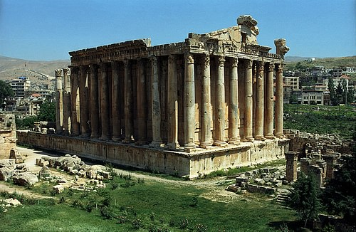](https://www.worldhistory.org/image/1318/temple-of-baachus-baalbek/)](https://www.worldhistory.org/image/1318/temple-of-baachus-baalbek/" \o "Temple of Baachus, Baalbek)**

[Temple of Baachus, Baalbek](https://www.worldhistory.org/image/1318/temple-of-baachus-baalbek/" \o "Temple of Baachus, Baalbek)

[Jerzy Strzelecki (CC BY-SA)](https://www.worldhistory.org/image/1318/temple-of-baachus-baalbek/" \o "Temple of Baachus, Baalbek)

**Temples** - The Roman temple was a combination of the [**Etruscan**](https://www.worldhistory.org/Etruscan_Civilization/) and Greek models with an inner cella at the rear of the building surrounded by columns and placed on a raised platform (up to 3.5 metres high) with a stepped entrance and columned porch, the focal point of the building (in contrast to Greek temples where all four sides could be equally important in the urban landscape). Surviving practically complete and a typical example is the Maison Carrée at Nimes (16 BCE). Temples were usually rectangular but could take other forms such as circular or polygonal, for example, the temple of [**Venus**](https://www.worldhistory.org/venus/) at Baalbeck (2nd-3rd century CE).

[**Remove Ads**](https://www.worldhistory.org/membership/?utm_source=whe&utm_medium=remove_ads_button_en&utm_campaign=membership)

Advertisement

**The fully enclosed amphitheatre was a particular favourite of the Romans. ​**

**Theatres & Amphitheatres** - The Roman [**theatre**](https://www.worldhistory.org/disambiguation/theatre/) was of course inspired by the Greek version, but the orchestra was made semicircular and the whole made using stone. The Romans also added a highly decorative stage building (*scaenae frons*) which incorporated different levels of columns, projections, pediments, and statues such as is found in the theatre at Orange (27 BCE - 14 CE). A similar approach was taken with façades of libraries - see, for example, the Celsus Library in [**Ephesus**](https://www.worldhistory.org/ephesos/) (2nd century CE). Theatres also display the Roman passion for enclosing spaces, especially as they were often (partially or completely) roofed in wood or employed canvas awnings.

The fully enclosed amphitheatre was a particular favourite of the Romans. The Colosseum is the largest and most famous, and it is a typical example copied throughout the empire: a highly decorative exterior, seats set over a network of barrel vaults, and underground rooms below the arena floor to hide people, animals and props until they were needed in the spectacles.

**[[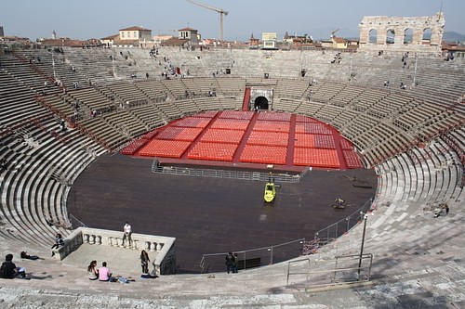](https://www.worldhistory.org/image/2481/roman-amphitheatre-verona/)](https://www.worldhistory.org/image/2481/roman-amphitheatre-verona/" \o "Roman Amphitheatre, Verona)**

[Roman Amphitheatre, Verona](https://www.worldhistory.org/image/2481/roman-amphitheatre-verona/" \o "Roman Amphitheatre, Verona)

[Mark Cartwright (CC BY-NC-SA)](https://www.worldhistory.org/image/2481/roman-amphitheatre-verona/" \o "Roman Amphitheatre, Verona)

**Triumphal Arches** - The triumphal arch, with a single, double, or triple entrance, had no practical function other than to commemorate in [**sculpture**](https://www.worldhistory.org/disambiguation/Sculpture/) and inscription significant events such as military victories. Early examples stood over thoroughfares - the earliest being the two arches set up by L.Stertinius in Rome (196 BCE) - but later examples were often protected by steps. Topped by a [**bronze**](https://www.worldhistory.org/disambiguation/bronze/) four-horse [**chariot**](https://www.worldhistory.org/chariot/), they became imposing stone monuments to Roman vanity. The Arch of [**Constantine**](https://www.worldhistory.org/disambiguation/Constantine/) (c. 315 CE) in Rome is the largest surviving example and is perhaps the last great monument of Imperial Rome.

**[[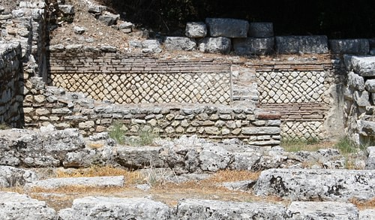](https://www.worldhistory.org/image/866/roman-opus-mixtum-wall/)](https://www.worldhistory.org/image/866/roman-opus-mixtum-wall/" \o "Roman Opus Mixtum Wall)**

[Roman Opus Mixtum Wall](https://www.worldhistory.org/image/866/roman-opus-mixtum-wall/" \o "Roman Opus Mixtum Wall)

[Mark Cartwright (CC BY-NC-SA)](https://www.worldhistory.org/image/866/roman-opus-mixtum-wall/" \o "Roman Opus Mixtum Wall)

**Walls** - Aside from the famous military structures such as the Antonine and [**Hadrian's Wall**](https://www.worldhistory.org/Hadrians_Wall/) (c. 142 CE and c. 122 CE respectively), even more modest [**Roman walls**](https://www.worldhistory.org/article/942/roman-walls/) offer a surprising number of variations. The width of Roman walls could also vary tremendously from the thinnest at 18 cm to a massive 6 m thick. Rarely were marble and fine stone blocks used as this was too expensive. Large square blocks were used to create ashlar masonry walls, that is, close-fitting blocks without any use of mortar. Much more common was the use of brick (usually triangular shaped and set with mortar) and small stones facing a concrete mix core. The bricks and stones could be arranged in various ways:

* *opus incertum* - first appeared in the 3rd century BCE and used small irregular chunks of stone smoothed on one side.
* *opus reticulatum* - from the 2nd century BCE and used [**pyramid**](https://www.worldhistory.org/pyramid/)-shaped chunks with 6-12 cm square base and height of 8-14 cm. The stone was set with the base facing outwards and laid in diagonal arrangements.
* *opus mixtum* - common from the 1st century CE, this was a combination of *opus reticulatum* with a layer (course) of horizontal brick every fourth course and at the edges of the wall.
* *opus testaceum* - common from the 1st century CE and used courses of brick only.
* *opus vittatum* - used an alternative course of brick with two courses of tufa blocks with a rectangular side facing outwards and diminishing in size towards the inner surface. It was especially popular from the 4th century CE across the Empire.

Despite the decorative effect of these various arrangements of stone and brick, most walls were actually covered both inside and out with white plaster stucco for protection against heat and rain for the outside and to provide a smooth surface for fine decorative wall painting on the inside.

**Conclusion**

Roman architecture, then, has provided us with magnificent structures that have, quite literally, stood the test of time. By combining a wide range of materials with daring designs, the Romans were able to push the boundaries of physics and turn architecture into an art form. The result was that architecture became an imperial tool to demonstrate to the world that Rome was culturally superior because only she had the wealth, skills, and audacity to produce such edifices. Even more significantly, the Roman use of concrete, brick, and arches twinned with building designs like the amphitheatre and basilica would immeasurably influence all following western architecture right up to the present day.

Roman Art

Definition



by [**Mark Cartwright**](https://www.worldhistory.org/user/markzcartwright/)  
published on 01 September 2017

Available in other languages: [**French**](https://www.worldhistory.org/trans/fr/1-10804/art-de-la-rome-antique/), [**Spanish**](https://www.worldhistory.org/trans/es/1-10804/arte-romano/), [**Turkish**](https://www.worldhistory.org/trans/tr/1-10804/roma-sanati/)

[Subscribe to topic](https://www.worldhistory.org/interestemails/?tags=Ancient_Rome+art+Byzantine_Art+Carthaginian_Art+Etruscan_Art+Greek_Art+italy+Roman_Art+Rome+Sculpture) [Subscribe to author](https://www.worldhistory.org/interestemails/?author=markzcartwright) Print Article PDF

**[[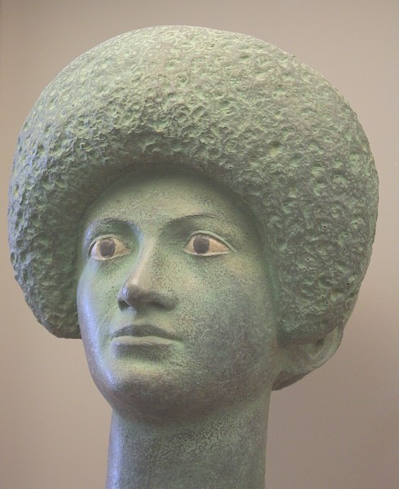](https://www.worldhistory.org/image/6101/roman-female-portrait/)](https://www.worldhistory.org/image/6101/roman-female-portrait/" \o "Roman Female Portrait)**

[Roman Female Portrait](https://www.worldhistory.org/image/6101/roman-female-portrait/" \o "Roman Female Portrait)

[Mark Cartwright (CC BY-NC-SA)](https://www.worldhistory.org/image/6101/roman-female-portrait/" \o "Roman Female Portrait)

The Romans controlled such a vast [**empire**](https://www.worldhistory.org/empire/) for so long a period that a summary of the art produced in that time can only be a brief and selective one. Perhaps, though, the greatest points of distinction for [**Roman**](https://www.worldhistory.org/disambiguation/Roman/) art are its very diversity, the embracing of art trends past and present from every corner of the empire and the promotion of art to such an extent that it became more widely produced and more easily available than ever before. In which other ancient [**civilization**](https://www.worldhistory.org/civilization/) would it have been possible for a former slave to have commissioned his portrait bust? Roman artists copied, imitated, and innovated to produce art on a grand scale, sometimes compromising quality but on other occasions far exceeding the craftsmanship of their predecessors. Any material was fair game to be turned into objects of art. Recording historical events without the clutter of symbolism and mythological metaphor became an obsession. Immortalising an individual private patron in art was a common artist's commission. Painting aimed at faithfully capturing landscapes, townscapes, and the more trivial subjects of daily life. Realism became the ideal and the cultivation of a knowledge and appreciation of art itself became a worthy goal. These are the achievements of Roman art.

**Art for All:**[**Rome**](https://www.worldhistory.org/Rome/)**'s Contribution**

Roman art has suffered something of a crisis in reputation ever since the rediscovery and appreciation of ancient [**Greek**](https://www.worldhistory.org/disambiguation/greek/) art from the 17th century CE onwards. When art critics also realised that many of the finest Roman pieces were in fact copies or at least inspired by earlier and often lost Greek originals, the appreciation of Roman art, which had flourished along with all things Roman in the medieval and Renaissance periods, began to diminish. Another problem with Roman art is the very definition of what it actually is. Unlike Greek art, the vast geography of the [**Roman empire**](https://www.worldhistory.org/Roman_Empire/) resulted in very diverse approaches to art depending on location. Although Rome long remained the focal point, there were several important art-producing centres in their own right who followed their own particular trends and tastes, notably at [**Alexandria**](https://www.worldhistory.org/alexandria/), [**Antioch**](https://www.worldhistory.org/Antiochia/), and [**Athens**](https://www.worldhistory.org/Athens/). As a consequence, some critics even argued there was no such thing as 'Roman' art.

[**Pompeii**](https://www.worldhistory.org/pompeii/)**, in particular, gives a rare insight into how Roman artworks were used, Combined & Enjoyed.**

In more recent times a more balanced view of Roman art and a wider one provided by the successes of [**archaeology**](https://www.worldhistory.org/Archaeology/) have ensured that the art of the Romans has been reassessed and its contribution to western art in general has been more greatly recognised. Even those holding the opinion that Classical Greek art was the zenith of artistic endeavour in the west or that the Romans merely fused the best of Greek and [**Etruscan art**](https://www.worldhistory.org/Etruscan_Art/) would have to admit that Roman art is nothing if not eclectic. Inheriting the [**Hellenistic world**](https://www.worldhistory.org/Hellenistic_Period/) forged by [**Alexander the Great**](https://www.worldhistory.org/Alexander_the_Great/)'s conquests, with an empire covering a hugely diverse spectrum of cultures and peoples, their own appreciation of the past, and clear ideas on the best way to commemorate events and people, the Romans produced art in a vast array of forms. Seal-cutting, jewellery, glassware, mosaics, [**pottery**](https://www.worldhistory.org/pottery/), frescoes, statues, monumental [**architecture**](https://www.worldhistory.org/disambiguation/architecture/), and even epigraphy and coins were all used to beautify the Roman world as well as convey meaning from military prowess to fashions in aesthetics.

**[[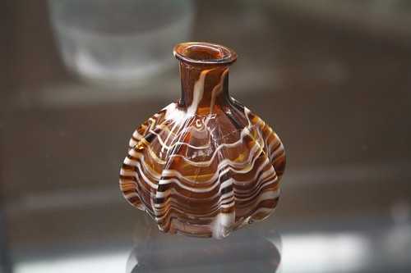](https://www.worldhistory.org/image/4595/roman-perfume-bottle/)](https://www.worldhistory.org/image/4595/roman-perfume-bottle/" \o "Roman Perfume Bottle)**

[Roman Perfume Bottle](https://www.worldhistory.org/image/4595/roman-perfume-bottle/" \o "Roman Perfume Bottle)

[Mark Cartwright (CC BY-NC-SA)](https://www.worldhistory.org/image/4595/roman-perfume-bottle/" \o "Roman Perfume Bottle)

Artworks were looted from conquered [**cities**](https://www.worldhistory.org/city/) and brought back for the appreciation of the public, foreign artists were employed in Roman cities, schools of art were created across the empire, technical developments were made, and workshops sprang up everywhere. Such was the demand for artworks, production lines of standardised and mass produced objects filled the empire with art. And here is another factor in Rome's favour, the sheer quantity of surviving artworks. Such sites as Pompeii, in particular, give a rare insight into how Roman artworks were used and combined to enrich the daily lives of citizens. Art itself became more personalised with a great increase in private patrons of the arts as opposed to state sponsors. This is seen in no clearer form than the creation of lifelike portraits of private individuals in paintings and [**sculpture**](https://www.worldhistory.org/disambiguation/Sculpture/). Like no other civilization before it, art became accessible not just to the wealthiest but also to the lower middle classes.

**Key Art forms**

[**Roman Sculpture**](https://www.worldhistory.org/Roman_Sculpture/)

Roman sculpture blended the idealised perfection of earlier Classical [**Greek sculpture**](https://www.worldhistory.org/Greek_Sculpture/) with a greater aspiration for realism and mixed in the styles prevalent in Eastern art. Roman sculptors have also, with their popular copies of earlier Greek masterpieces, preserved for posterity invaluable works which would have otherwise been completely lost to world art.

**[[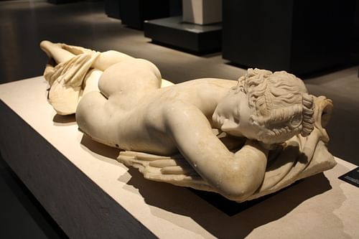](https://www.worldhistory.org/image/1178/sleeping-hermaphrodite/)](https://www.worldhistory.org/image/1178/sleeping-hermaphrodite/" \o "Sleeping Hermaphrodite)**

[Sleeping Hermaphrodite](https://www.worldhistory.org/image/1178/sleeping-hermaphrodite/" \o "Sleeping Hermaphrodite)

[Mark Cartwright (CC BY-NC-SA)](https://www.worldhistory.org/image/1178/sleeping-hermaphrodite/" \o "Sleeping Hermaphrodite)

The Romans favoured [**bronze**](https://www.worldhistory.org/disambiguation/bronze/) and marble above all else for their finest work. However, as [**metal**](https://www.worldhistory.org/disambiguation/metal/) has always been in high demand for reuse, most of the surviving examples of Roman sculpture are in marble. The Roman taste for Greek and [**Hellenistic**](https://www.worldhistory.org/Hellenic_World/) sculpture meant that once the supply of original pieces had been exhausted sculptors had to make copies, and these could be of varying quality depending on the sculptor's skills. Indeed, there was a school specifically for copying celebrated Greek originals in Athens and Rome itself. Roman sculptors also produced miniaturised copies of Greek originals, often in bronze, which were collected by art-lovers and displayed in cabinets in the home.

**Private portrait busts sometimes present the subject as old, wrinkled, scarred, or flabby; in short, these portraits tell the truth.**

Roman sculpture did, however, begin to search for new avenues of artistic expression, moving away from their [**Etruscan**](https://www.worldhistory.org/Etruscan_Civilization/) and Greek roots, and, by the mid-1st century CE, Roman artists were seeking to capture and create optical effects of light and shade for greater realism. The realism in Roman portrait sculpture and funerary art may well have developed from the tradition of keeping realistic wax funeral masks of deceased family members in the ancestral home. Transferred to stone, we then have many examples of private portrait busts which sometimes present the subject as old, wrinkled, scarred, or flabby; in short, these portraits tell the truth. By later antiquity, there was even a move towards [**impressionism**](https://www.worldhistory.org/Impressionism/) using tricks of light and abstract forms. Sculpture also became more monumental with massive, larger-than-life statues of emperors, gods, and heroes, such as the huge bronze statue of [**Marcus Aurelius**](https://www.worldhistory.org/Marcus_Aurelius/) on horseback now in the Capitoline Museum, Rome. Towards the end of the Empire, sculpture of figures tended to lack proportion, heads especially were enlarged, and figures were most often presented flatter and from the front, displaying the influence of Eastern art.

**[[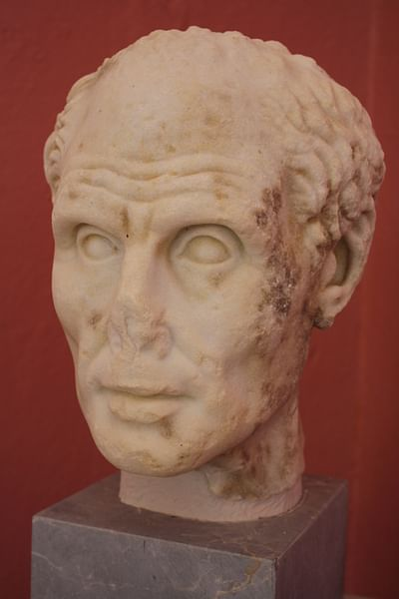](https://www.worldhistory.org/image/2059/roman-portrait-bust/)](https://www.worldhistory.org/image/2059/roman-portrait-bust/" \o "Roman Portrait Bust)**

[Roman Portrait Bust](https://www.worldhistory.org/image/2059/roman-portrait-bust/" \o "Roman Portrait Bust)

[Mark Cartwright (CC BY-NC-SA)](https://www.worldhistory.org/image/2059/roman-portrait-bust/" \o "Roman Portrait Bust)

Sculpture on Roman buildings and altars could be merely decorative or have a more political purpose. For example, on triumphal arches the architectural sculpture captured in detail key campaign events, which reinforced the message that the emperor was a victorious and civilizing agent across the known world. A typical example is the Arch of [**Constantine**](https://www.worldhistory.org/disambiguation/Constantine/) in Rome (c. 315 CE) which also shows defeated and enslaved 'barbarians' to ram home the message of Rome's superiority. Such a portrayal of real people and specific historical figures in architectural sculpture is in marked contrast to Greek sculpture where great military victories were usually presented in metaphor, using figures from [**Greek mythology**](https://www.worldhistory.org/Greek_Mythology/) like [**amazons**](https://www.worldhistory.org/amazon/) and centaurs such as on the [**Parthenon**](https://www.worldhistory.org/parthenon/). Altars could also be used to present important individuals in a favourable light. The most famous altar of all is the Ara Pacis of [**Augustus**](https://www.worldhistory.org/augustus/) (completed 9 BCE) in Rome, a huge block of masonry which depicts spectators and participants at a religious procession. It seems as though the figures have been captured in a single moment as in a photograph, a child pulls on a toga, Augustus' sister tells two chatterers to be silent, and so on.

**Roman**[**Wall**](https://www.worldhistory.org/wall/)**Paintings**

The interiors of Roman buildings of all description were very frequently sumptuously decorated using bold colours and designs. Wall paintings, [**fresco**](https://www.worldhistory.org/disambiguation/Fresco/), and the use of stucco to create relief effects were all commonly used by the 1st century BCE in public buildings, private homes, temples, tombs, and even military structures across the Roman world. Designs could range from intricate realistic detail to highly impressionistic renderings which frequently covered all of the available wall space including the ceiling.

**[[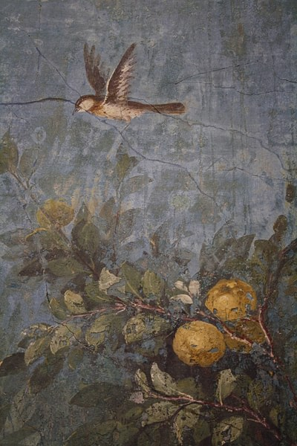](https://www.worldhistory.org/image/1161/fresco-livias-villa-rome/)](https://www.worldhistory.org/image/1161/fresco-livias-villa-rome/" \o "Fresco, Livia's Villa, Rome)**

[Fresco, Livia's Villa, Rome](https://www.worldhistory.org/image/1161/fresco-livias-villa-rome/" \o "Fresco, Livia's Villa, Rome)

[Mark Cartwright (CC BY-NC-SA)](https://www.worldhistory.org/image/1161/fresco-livias-villa-rome/" \o "Fresco, Livia's Villa, Rome)

Roman wall painters (or perhaps their clients) preferred natural earth colours such as darker shades of reds, yellows, and browns. Blue and black pigments were also popular for plainer designs, but evidence from a Pompeii paint shop illustrates that a wide range of colour shades was available. Subjects could include portraits, scenes from [**mythology**](https://www.worldhistory.org/mythology/), architecture using *trompe-l'oeil*, flora, fauna, and even entire gardens, landscapes and townscapes to create spectacular 360° panoramas which transported the viewer from the confines of a small room to the limitless world of the painter's imagination. An outstanding example is the 1st century BCE House of [**Livia**](https://www.worldhistory.org/Livia_Drusilla/) on the Palatine hill in Rome which includes a 360° panorama of an impressionistically rendered garden. The scene runs around one room and completely ignores the corners. Another splendid example is the 1st century CE private villa known as the House of the Vettii in Pompeii.

As the art form developed, larger-scale single scenes which presented larger-than-life figures became more common. By the 3rd century CE one of the best sources of wall painting comes from Christian catacombs where scenes were painted from both the Old and [**New Testament**](https://www.worldhistory.org/New_Testament/).

[**Roman Mosaics**](https://www.worldhistory.org/article/498/roman-mosaics/)

Roman mosaics were a common feature of private homes and public buildings across the empire from [**Africa**](https://www.worldhistory.org/disambiguation/africa/) to Antioch. Mosaics, otherwise known as *opus tessellatum*, were made with small black, white, and coloured squares of marble, tile, glass, pottery, stone, or shells. Typically, each individual piece measured between 0.5 and 1.5 cm but fine details, especially in the central panel (*emblemata*) were often rendered using even smaller pieces as little as 1mm in size. Designs employed a wide spectrum of colours with coloured grouting to match surrounding *tesserae*. This particular type of [**mosaic**](https://www.worldhistory.org/Mosaic/) which used sophisticated colouring and shading to create an effect similar to a painting is known as *opus vermiculatum,* and one of its greatest craftsmen was Sorus of [**Pergamon**](https://www.worldhistory.org/pergamon/) (150-100 BCE) whose work, especially his Drinking Doves mosaic, was much copied for centuries after.

**[[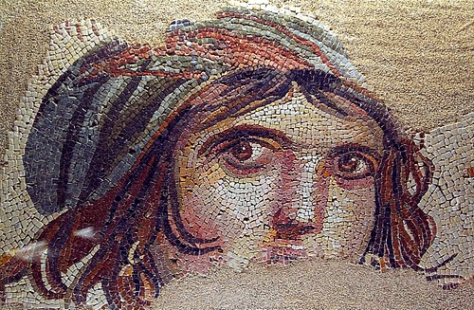](https://www.worldhistory.org/image/2728/mosaic-of-a-gypsy-girl/)](https://www.worldhistory.org/image/2728/mosaic-of-a-gypsy-girl/" \o "Mosaic of a Gypsy Girl)**

[Mosaic of a Gypsy Girl](https://www.worldhistory.org/image/2728/mosaic-of-a-gypsy-girl/" \o "Mosaic of a Gypsy Girl)

[James Gordon (CC BY)](https://www.worldhistory.org/image/2728/mosaic-of-a-gypsy-girl/" \o "Mosaic of a Gypsy Girl)

Popular subjects included scenes from mythology, [**gladiator**](https://www.worldhistory.org/gladiator/) contests, sports, [**agriculture**](https://www.worldhistory.org/disambiguation/Agriculture/), hunting, food, flora and fauna, and sometimes they even captured the Romans themselves in detailed and realistic portraits. One the most famous Roman mosaics today is one from the House of the Faun, Pompeii, which depicts [**Alexander**](https://www.worldhistory.org/disambiguation/Alexander/) the Great riding [**Bucephalus**](https://www.worldhistory.org/Bucephalus/) and facing [**Darius**](https://www.worldhistory.org/disambiguation/darius/) III on his [**war**](https://www.worldhistory.org/war/) [**chariot**](https://www.worldhistory.org/chariot/). Not just floors but also vaults, columns, and fountains were decorated with mosaic designs too.

Roman mosaics artists developed their own styles, and production schools were formed across the empire which cultivated their own particular preferences - large-scale hunting scenes and attempts at perspective in the African provinces, impressionistic vegetation and a foreground observer in the mosaics of Antioch, or the European preference for figure panels, for example. The dominant (but not exclusive) Roman style in [**Italy**](https://www.worldhistory.org/italy/) itself used only black and white *tesserae*, a taste which survived well into the 3rd century CE and was most often used to represent marine motifs, especially when used for [**Roman baths**](https://www.worldhistory.org/Roman_Baths/). Over time the mosaics became ever more realistic in their portrayal of human figures, and accurate and detailed portraits become more common. Meanwhile, in the Eastern part of the empire and especially at Antioch, the 4th century CE saw the spread of mosaics which used two-dimensional and repeated motifs to create a 'carpet' effect, a style which would heavily influence later Christian churches and Jewish synagogues.

**Minor Arts**

The minor arts of ancient Rome were wide and varied, illustrating in many cases the Roman love of finely worked precious materials with detail and often miniaturised designs. They included jewellery of all kinds, small [**gold**](https://www.worldhistory.org/gold/) portrait busts, silverware such as mirrors, cups, plates, figurines etc., gem-cutting and engraving, sardonyx cameos, seals, vessels and ornaments in cut-glass, inlaid, gilded or enamelled bronze vessels, carved and engraved ivories, fine decorated pottery, plaques for addition to furniture, elements of military uniforms and weapons, medallions, coins, terracotta oil lamps, embroidered [**Tyrian purple**](https://www.worldhistory.org/Tyrian_Purple/) cloth, and illustrated books. Subjects of decoration included the imperial family, private individuals, mythology, nature, and such standard motifs as geometrical shapes, acanthus leaves, vines, meanders, rosettes, and swastikas. Works are often signed by the craftsman, who may be foreign or Roman.

[[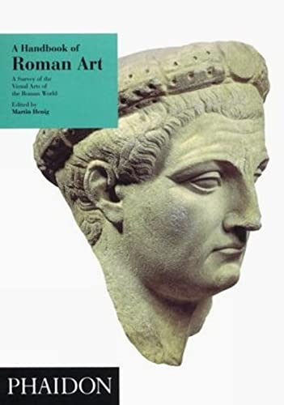](https://www.amazon.com/dp/0714823015?tag=anciehistoenc-20&linkCode=ogi&th=1&psc=1)](https://www.amazon.com/dp/0714823015?tag=anciehistoenc-20&linkCode=ogi&th=1&psc=1)

[Book Recommendation](https://www.amazon.com/dp/0714823015?tag=anciehistoenc-20&linkCode=ogi&th=1&psc=1)

**[A Handbook of Roman Art: A Survey of the Visual Arts of the Roman World](https://www.amazon.com/dp/0714823015?tag=anciehistoenc-20&linkCode=ogi&th=1&psc=1)**

[by Tom Rasmussen & Anthony Bonanno & Joan Liversidge & David Smith & Richard Reece & Anthony King & Donald Bailey & Jennifer Price & Robert Ireland & Martin Henig](https://www.amazon.com/dp/0714823015?tag=anciehistoenc-20&linkCode=ogi&th=1&psc=1)

[published by Phaidon Press Limited (1994)](https://www.amazon.com/dp/0714823015?tag=anciehistoenc-20&linkCode=ogi&th=1&psc=1)

[$2.92](https://www.amazon.com/dp/0714823015?tag=anciehistoenc-20&linkCode=ogi&th=1&psc=1)

**[[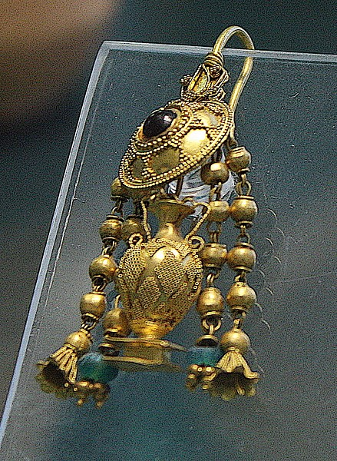](https://www.worldhistory.org/image/7038/gold-filigree-earring-herakleia/)](https://www.worldhistory.org/image/7038/gold-filigree-earring-herakleia/" \o "Gold Filigree Earring, Herakleia)**

[Gold Filigree Earring, Herakleia](https://www.worldhistory.org/image/7038/gold-filigree-earring-herakleia/" \o "Gold Filigree Earring, Herakleia)

[Mark Cartwright (CC BY-NC-SA)](https://www.worldhistory.org/image/7038/gold-filigree-earring-herakleia/" \o "Gold Filigree Earring, Herakleia)

Items of silverware and carved gems were especially appreciated and frequently collected by those Romans who could afford them. Kept in the home, they would, no doubt, have been shown to admiring visitors and used as conversation pieces. The Roman love for intricately detailed and tiny carvings on gems counters the traditional view that Roman art was preoccupied with all that was massive and inelegantly bulky. Signet rings, a symbol of family pride and an important method of signature along with seal-stones, were, like gemstones, carved using small drills with a diamond point or lap-wheel which were rotated using a horizontal bow on the shaft. Cornelian and onyx seem to have been the material of choice for more functional items, but sapphires and aquamarine are amongst the more precious gems the Romans imported from such far-flung places as [**India**](https://www.worldhistory.org/india/).

Roman jewellers were especially skilled in their craft. Learning from those who had gone before, they employed the full range of metalworking skills such as gilding, granulation, repousse, inlay, open-work etc. Rings, necklaces, bracelets, brooches, buckles, earrings, pendants, anklets, and hair nets were all produced in precious metals, often with extraordinary detail and craftsmanship. As time went on, jewellery generally became heavier and more flashy and was by no means limited to [**women**](https://www.worldhistory.org/disambiguation/women/)'s dress.

**Legacy**

In many ways, the Romans continued and perpetuated the arts of earlier civilizations, but as the art historian Martin Henig here summarises, their artistic efforts came to much more than that:

Roman achievement…totally belies the [**philistine**](https://www.worldhistory.org/Philistines/) reputation that has been popularly ascribed to ancient Rome. Inheriting the Greek traditions, Roman craftsmen continued to innovate, and their work never ceases to astonish us by its delicacy of form. (Henig, 165)

Contributions from Roman art to the general development of western art include a determination to record actual historical events; wall paintings in different styles which captured the architecture of the day, natural views or still life - including people and ordinary objects which were rarely previously depicted in art; and realistic portraiture of humble citizens. None of these was wholly new in art but the Romans, as in so many other fields, pushed the possibilities of an idea to its limits and beyond.

**[[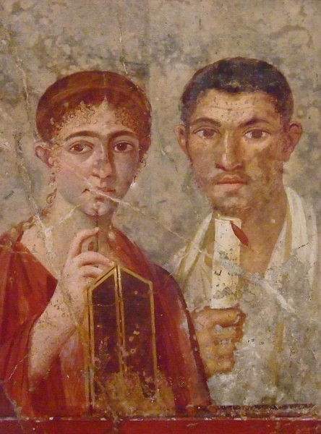](https://www.worldhistory.org/image/961/fresco-pompeii/)](https://www.worldhistory.org/image/961/fresco-pompeii/" \o "Fresco, Pompeii)**

[Fresco, Pompeii](https://www.worldhistory.org/image/961/fresco-pompeii/" \o "Fresco, Pompeii)

[Mary Harrsch (Photographed at the Museo Archaeologico Nazionale di Napoli) (CC BY-SA)](https://www.worldhistory.org/image/961/fresco-pompeii/" \o "Fresco, Pompeii)

By the end of the Roman period new ideas in art were developing and would continue to do so, but Roman art would have a lasting effect on all who followed, not least in medieval Christian art and drawings on manuscripts. Perhaps, though, their greatest contribution to world art was the fostering of the idea that the appreciation of art for its own sake was a fine thing and that to possess art objects or even a collection was a real badge of one's cultural sophistication. In addition, even for those who could not afford their own art, there was the provision of public art galleries. Art was no longer the exclusive domain of the rich, art was for anyone and everyone. The Romans, like no other [**culture**](https://www.worldhistory.org/disambiguation/culture/) before them, were champions of art as a popular, affordable, and accessible means of expressing and communicating the human spirit.